MANAGERS TEAM RELATE
Within your EV People Homepage, navigate to the relevant colleagues profile and select the ‘Overview’ option (if you are not automatically routed)

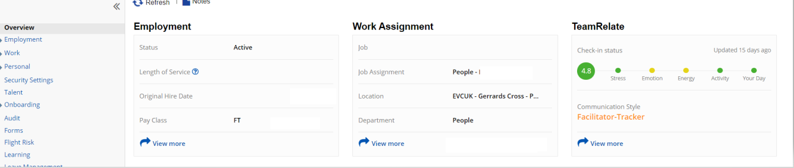
Select ‘View More’ in the Team Relate section.
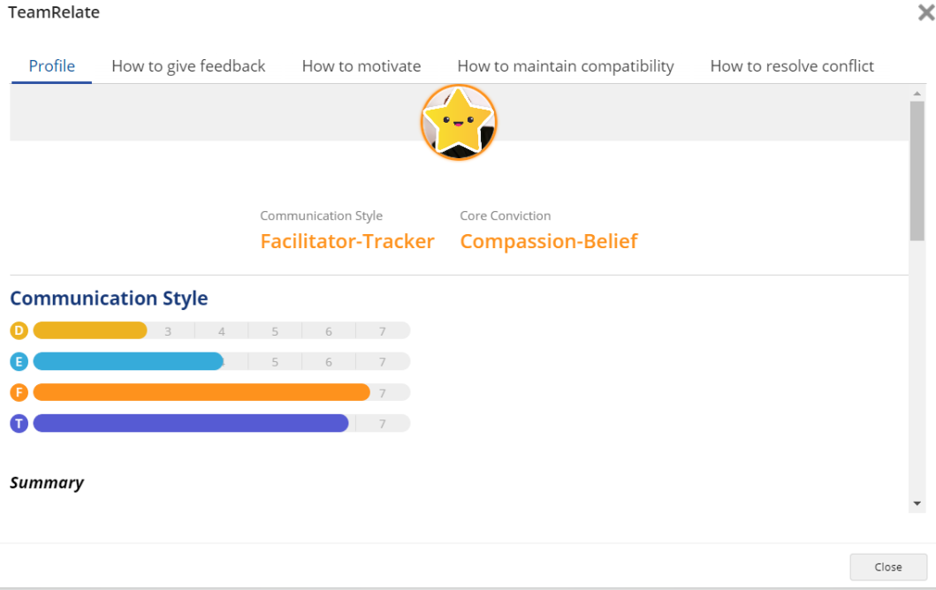
Within this area you will have access to how this individual prefers to:
- Receive feedback
- Be motivated
- Maintain compatibility
- Resolve conflict
These tools can be used in team building, preference awareness, preparing for difficult conversations, performance management discussions and much more…

